Utility Wind Step 3: Tower Module

Table of Contents

Descriptive Information 2

Descriptive Text of Value Chain Step 2

Relevant Figures (if any) 4

References 4

Y=Innovative Outcomes 4

Direction and rate of technological change (text) 4

Illustrations 6

Data on Quantity, Cost, Quality 6

Tech Trend Table that would let someone else build a learning curve/experience curve 6

Additional text on quantity cost quality data (e.g., widget cost: XX (reference); widget beauty: YY (reference) 7

References 7

X= Strategic Conditions 7

Porter's 5 Forces diagram of this value chain step (governance, related industries relevant) 7

Market structure text (and maybe accompanying illustration) 7

Overview of Geography (as it relates to imperfect competition) 8

Overview of Governance (as it related to imperfect competition) 8

Illustrations if relevant (e.g., time-series of M&A -- see wind example) 8

Quantitative treatment of imperfect competition w/ accompanying descriptive text 9

FFCR with NAICS codes 9

HHI if possible - either we calculate based on table below or we cite somebody else's calculation 9

Firm Economic Data Table 9

References 9

X = Knowledge Conditions 9

# Descriptive Information

## Descriptive Text of Value Chain Step

|  |
| --- |
| *(1) For dummies (engineering/business). What is the object and/or business at this value chain step? How does the business work in this value chain step. [A couple of sentences]. (2) This step in the value chain is covered by "..." (6-digit NAICS code)" and Y standards/FTC codes etc...(think Joanna Lewis and Global Trade Alerts)* |

Towers are the structural base of the wind turbine that carry the rotor and the nacelle module. There are three main types of towers used in large wind turbines: (1) tubular steel towers, (2) lattice towers, and (3) hybrid tower. (<http://ele.aut.ac.ir/~wind/en/tour/wtrb/tower.htm>)

Most modern wind turbine towers are conical tubular steel towers. They generally are made from three or four sections for easier transportation and are assembled on site. Each section consists of metal rings that are thickest at the bottom and gradually become narrower at the top. During the manufacturing process, steel plate is cut and rolled into the conical shape and then welded into rings. These metal rings are assembled together with vertical joint and then coated with different sealants to compose a complete tower section. (IBIS, AWEA 2011) According to the cost report by National Renewable Energy Laboratory (NREL), the tower module accounts for approximately 16.5% of the one-shore wind power project cost in 2015.2 Figure below illustrates steps of the manufacturing process of a tubular steel tower.

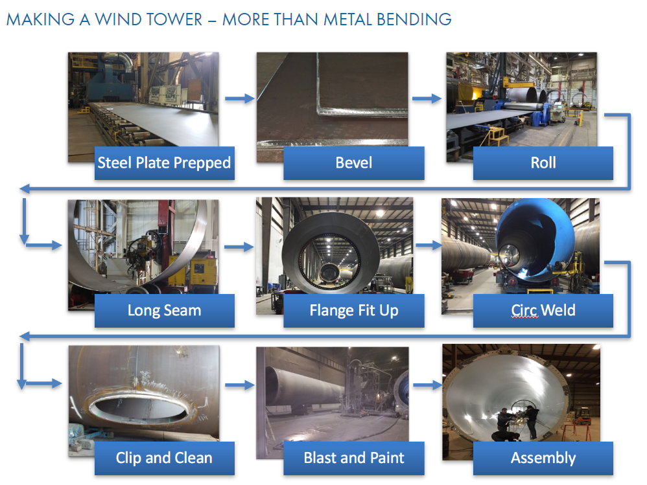

Source: Broadwind Energy (<http://www.bwen.com/products/wind-turbine-towers/strategic-manufacturing-locations/default.aspx>)

To reduce the transportation costs, most of the tower manufacturing facilities are strategically located in close proximity to their customers or rail lines and deepwater transportation ports for efficient shipping of tower sections. Broadwind Towers, Marmen Energy, Trinity Structural Towers, Ventower and Vestas make up to the vast majority of rotor blade manufacturing capacity in the U.S. As in 2016, there are nine tower manufacturing facilities in operation in the U.S., which are capable of producing approximately 3,150 towers annually.1

The tower manufacturing is part of *“Turbine and Turbine Generator Set Units Manufacturing”* (NAICS 333611).[1] As reported in the 2012 Economic Census, there are 183 establishments, 36,955 employees covered under this industry with a value of shipments of 16.9 billion dollars. However, even at their most disaggregated level (six-digit code), each of the NAICS code covers a range of components, products, and services beyond those specific to tower manufacturing.

## Relevant Figures (if any)

|  |
| --- |
| *Don't go crazy on this. And look first for stock/DOE images (i.e., no copyright issue)* |

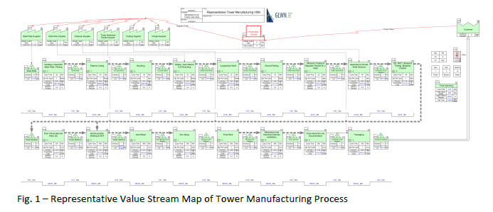

Source: GLWN (2014) U.S. Wind Energy Manufacturing and Supply Chain: A Competitiveness Analysis

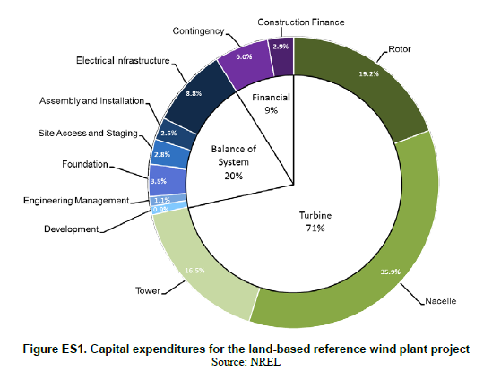

Source: NREL, 2015 Cost of Wind Energy Review

## References

|  |
| --- |
| *Only what we cite for text above and figures. Expansion of this is a nice-to-have to build on later* |

# Y=Innovative Outcomes

## Direction and rate of technological change (text)

|  |
| --- |
| *(1) The quality factors (i.e., performance attributes and/or cost) that guide this value chain step are ... (= direction of tech change; e.g., the blades are getting longer and lighter and more resilient (the reason for this is to support the increasing size of turbines, but this gets covered on the operations tab)). (2) Innovation/competition has resulted in a (dominant design or competing alternative designs). (3) Describe design(s). (4) Maybe (nice to have) something on rate of tech change (e.g., mature technology). (5) Maybe (nice to have) how industry is pushing to improve the technology (think incremental innovation or push to more radical innovation). (6) ... THIS WILL INCLUDE REFERENCE TO THE PREVIOUS Dominant design overview text. incremental innovation trends - how is industry pushing to improve the technology now. New developments (qualitative information on potentially emerging technologies, niche technologies – things that speak to the threat to the dominant design posed by substitutes and/or new entrants)* |

As the structural base of wind turbine, being able to achieve structural reliability is key to the design of tower. The tower must be built so it can handle the heavy static loads applied due to direct wind pressure and turbine bine load. In addition, the tower design is optimized by considering the energy yield gain and costs. Figure XX below demonstrates a trend towards taller tower height over time and it is mainly motivated by the rotor blade diameter, which has also been increasing in the past two decades. As the tower height increases, wind turbines would have access to steadier wind speed profile at higher altitudes and generate high power output for a given turbine rating and rotor diameter. In the current market, tubular steel towers are the most prominent design because of its high strength to weight ratio and competitive cost. However, the growing demand of taller tower has posed several transportation challenges, such as large crane requirement, higher site development cost and potentially long lead time. Therefore, concrete-made towers increasingly emerge as an alternative to tubular steel towers supported by potential cost savings in transportation and site development, no local buckling problems and more corrosion resistance. Another design alternative, hybrid steel-concrete towers, combined the advantage of tubular steel sections on top and concrete base on bottom. This hybrid design reduces the challenges of transporting large diameter steel-tubes and makes its seismic weight lower than concrete towers. (Serrano-González and Lacal-Arántegui, 2016)

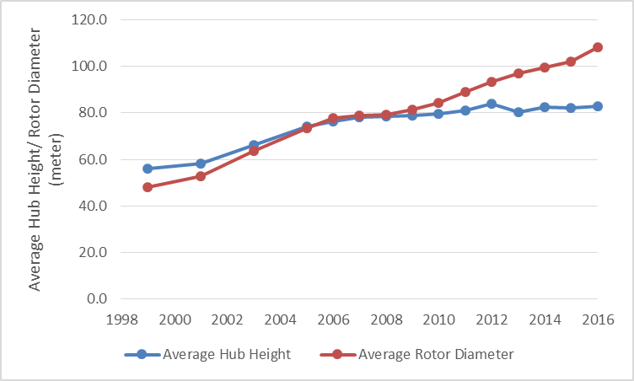

**Figure 1: Trends in Turbine Hub Height and Rotor Diameter**

Overall, the focus of research and development in the tower industry is to find ways to drive down the transportation costs through shipping towers in smaller components and completing most installation on-site.

**References:**

IBIS

<http://ele.aut.ac.ir/~wind/en/tour/wtrb/tower.htm>

<http://home.eng.iastate.edu/~jdm/wind/REU_Course_-_Tower_and__Foundation_-_June_2011.pdf>

<https://www.slideshare.net/AakashBagchi/design-and-construction-of-wind-turbine-towers-for-maximum-power-generation>

<http://www.bwen.com/products/wind-turbine-towers/strategic-manufacturing-locations/default.aspx>

GE -- Space Frame Wind Turbine Tower: <https://www.gerenewableenergy.com/wind-energy/technology/space-frame-tower>

## Illustrations

|  |
| --- |
| *Dominant design overview image (eg flow diagram, photo)* |

## Data on Quantity, Cost, Quality

### Tech Trend Table that would let someone else build a learning curve/experience curve

|  |  |  |  |  |  |  |  |  |
| --- | --- | --- | --- | --- | --- | --- | --- | --- |
| *Only exists if we have year and one or more of quantity cost quality*  ***Table Properties:***   |  |  | | --- | --- | | Year | If no time-series available, do one row with the year either current or tied to a specific reference | | Quantity | i) Quantity of relevance (e.g., shipments, # of projects/installations, power generated, etc.) - (to enable learning curve calcs) | | Cost | ii) Cost (to enable learning curve calcs) | | Quality/attributes |  | |

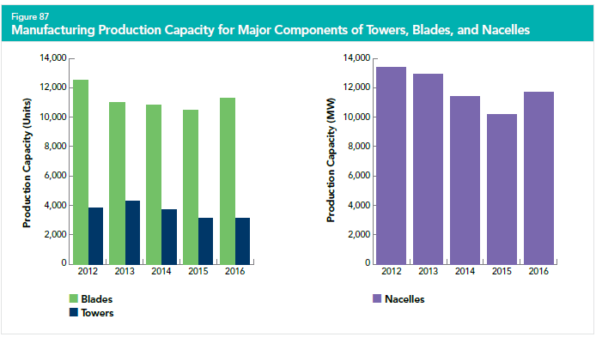

Source: AWEA 2016 Wind Industry Annual Market Report

### Additional text on quantity cost quality data (e.g., widget cost: XX (reference); widget beauty: YY (reference)

|  |
| --- |
| *Only exists if one of the three (quantity, cost, quality) has a year and the others don't* |

## References

# X= Strategic Conditions

## Porter's 5 Forces diagram of this value chain step (governance, related industries relevant)

|  |
| --- |
| *(modified/modeled on ibis world pic; cool if we could do with pie charts on supply and customer steps in vc based on 3 underlying spreadsheets of data.* |

## Market structure text (and maybe accompanying illustration)

|  |
| --- |
| *Current! Competitive landscape re: this value chain step only!! Relevant topics include: major firms, firm size, m&A (entry/exit), information on concentration and competition, vertical integration, barriers to entry (e.g., capital requirements, hard to get finance, lack of/need for highly skilled labor, infrastructure -- like only so many pipelines to sell aggregated natural gas into), make/buy/ally that underlies vertical integration, new competitors, current competitor/substitutes. Pull from previous "market snapshots" and "firm text" in spreadsheets.* |

### Overview of Geography (as it relates to imperfect competition)

|  |
| --- |
| *HQs. Global demand? Global supply? Leading firms and geography. How tied to governance.* |

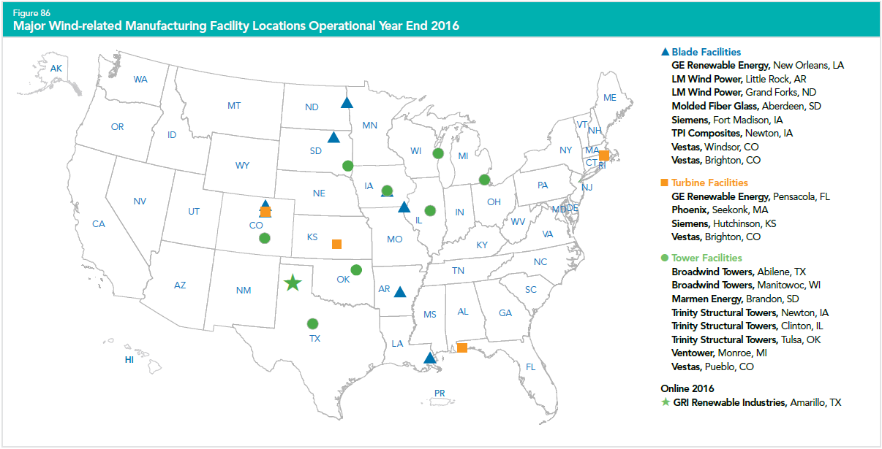

Source: AWEA 2016 Wind Industry Annual Market Report

**Figure 2: Map of Major Wind-related Manufacturing Facility Locations in 2016**

**Table 1: List of Tower Manufacturers in the United States**

|  |  |  |  |  |
| --- | --- | --- | --- | --- |
| **Company Name** | **Location** | **Land-based/Offshore** | **Coast** | **Notes** |
| Broadwind Towers | Abilene, TX | Both | No | Capabilities exist. Current tower supplier. Not coastal but transportable via rail to the Gulf |
| Broadwind Towers | Manitowoc, WI | Both | Great Lakes | Capability exists. Current tower supplier. |
| Marmen Energy | Brandon, SD | Land-based | No | Capability exists. Current tower supplier. |
| Trinity Structural Tower | Newton, IA | Land-based | No | Capability exists. Current tower supplier. |
| Trinity Structural Tower | Clinton, IL | Land-based | No | Capability exists. Current tower supplier. |
| Trinity Structural Tower | Tusla, OK | Land-based | No | Capability exists. Current tower supplier. |
| Ventower | Monroe, MI | Both | Great Lakes | Capability exists. Current tower supplier. |
| Vestas | Pueblo, CO | Land-based | No | Capability exists. Current tower supplier. |

Source: GLWN, U.S. Wind Energy Manufacturing and Supply Chain Competitiveness Analysis (2014)

### Overview of Governance (as it related to imperfect competition)

|  |
| --- |
| *Reminder: could be international trade, national laws, regional interconnection, state, local; institutions, maybe major laws/regs)* |

### Illustrations if relevant (e.g., time-series of M&A -- see wind example)

|  |
| --- |
| *Reminder: could be international trade, national laws, regional interconnection, state, local; institutions, maybe major laws/regs)* |

## Quantitative treatment of imperfect competition w/ accompanying descriptive text

|  |
| --- |
| (HHI best, FFCR easiest/most consistent) - maybe down to level of 8-12 firms (but if do this, please explain value) |

### FFCR with NAICS codes

|  |
| --- |
| *Needs accompanying text that 6 digit NAICS codes are broader and what FFCR is and how to interpret. The age of this data and what we expect about timing of updated data. Txt with table w NAICS fields (establishments, employees, shipments, number of companies, … [consolidate 2 NAICS code tables]* |

### HHI if possible - either we calculate based on table below or we cite somebody else's calculation

## Firm Economic Data Table

|  |
| --- |
| Current data! (according to data needed for HHI calculations, at least – not sure what data beyond this goes into horizontal merger analysis by antitrust folks) |

Table 2: Finances and Statistics of Major Tower Manufacturers in the United States

|  |  |  |  |  |  |  |
| --- | --- | --- | --- | --- | --- | --- |
| **Firm Name** | **Revenue** | **Quantity of relevance (e.g., shipments, # of projects/installations, power generated, etc.) - (to enable imperfect competition calculations)** | **Market share** | **HQ Location** | **Ticker symbol (if available)** | **Web address of firm annual report** |
| Broadwind Towers |  |  |  |  |  | http://www.bwen.com/products/wind-turbine-towers/default.aspx |
| Marmen Energy |  |  |  |  |  | http://www.marmeninc.com/en/expertises/wind-towers/ |
| Trinity Structural Tower |  |  |  |  |  | http://www.trinitytowers.com/the-tsti-difference.html |
| Ventower |  |  |  |  |  | http://www.ventower.com/ |
| Vestas |  |  |  |  |  |  |

## References

# X = Knowledge Conditions

1. “Turbine and Turbine Generator Set Units Manufacturing” industry (NAICS 333611) comprises establishments primarily engaged in manufacturing turbines (except aircraft); and complete turbine generator set units, such as steam, hydraulic, gas, and wind.